Tutorial 7

Ex1: Given following diagram, write SQL query based on diagram given

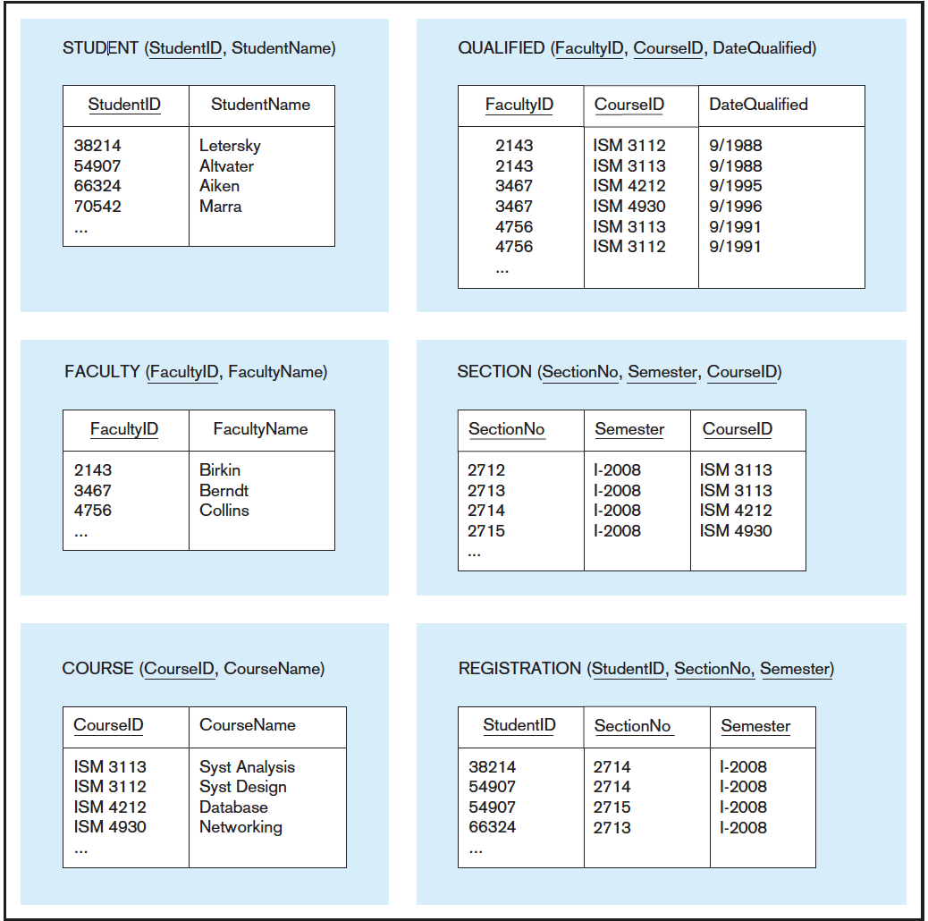

1. Display the course ID and course name for all courses with an ISM prefix.
2. Display all courses for which Professor Berndt has been qualified.

[select](http://localhost/phpmyadmin/url.php?url=https://dev.mysql.com/doc/refman/5.5/en/select.html) course.courseId, course.courseName from course, qualified, faculty where faculty.facultyName='Berndt' [and](http://localhost/phpmyadmin/url.php?url=https://dev.mysql.com/doc/refman/5.5/en/logical-operators.html#operator_and) course.courseId=qualified.courseId [and](http://localhost/phpmyadmin/url.php?url=https://dev.mysql.com/doc/refman/5.5/en/logical-operators.html#operator_and) faculty.facultyId=qualified.facultyId

1. Write an SQL query to answer the following question: Which faculty are qualified to teach ISM 3113?

“[SELECT](http://localhost/phpmyadmin/url.php?url=https://dev.mysql.com/doc/refman/5.5/en/select.html) faculty.facultyId, faculty.facultyName from faculty, course, qualified where course.courseId="ISM 3113" [and](http://localhost/phpmyadmin/url.php?url=https://dev.mysql.com/doc/refman/5.5/en/logical-operators.html#operator_and) faculty.facultyId=qualified.facultyId [and](http://localhost/phpmyadmin/url.php?url=https://dev.mysql.com/doc/refman/5.5/en/logical-operators.html#operator_and) qualified.courseId=course.courseId”

d. Write an SQL query to answer the following question: Is any instructor qualified to teach ISM 3113 and not qualified to

teach ISM 4930?

[select](http://localhost/phpmyadmin/url.php?url=https://dev.mysql.com/doc/refman/5.5/en/select.html) faculty.facultyId, faculty.facultyName from course, faculty, qualified WHERE course.courseId="ISM 3113" [and](http://localhost/phpmyadmin/url.php?url=https://dev.mysql.com/doc/refman/5.5/en/logical-operators.html#operator_and) course.courseId!="ISM 4930" [and](http://localhost/phpmyadmin/url.php?url=https://dev.mysql.com/doc/refman/5.5/en/logical-operators.html#operator_and) qualified.courseId=course.courseId [and](http://localhost/phpmyadmin/url.php?url=https://dev.mysql.com/doc/refman/5.5/en/logical-operators.html#operator_and) faculty.facultyId=qualified.facultyId

e. Write SQL queries to answer the following questions:

How many students were enrolled in section 2714 during semester I-2008?

How many students were enrolled in ISM 3113 during semester I-2008? (inner join)

f. Write an SQL query to answer the following question:

Which students were not enrolled in any courses during semester I-2008?

Ex 2

2. How many tutors have a status of Temp Stop? Which tutors are active? 3. List the tutors who took the certification class in January.

4. Which tutors, by name, are available to tutor? Write the SQL command.

5. How many students were matched with someone in the first five months of the year?

6. List students ranking from max Read Score to min Read Score? Which student has highest read score.